Cairo University

Faculty of Engineering

Security Task

To: Eng. Mohamed Abdelhalim

Team Members:

Amr Doma (1210273)

Tarek Waleed (1210246)

Habiba Walid (1210215)

# Test Vulnerabilities

## SQL Injection on Login

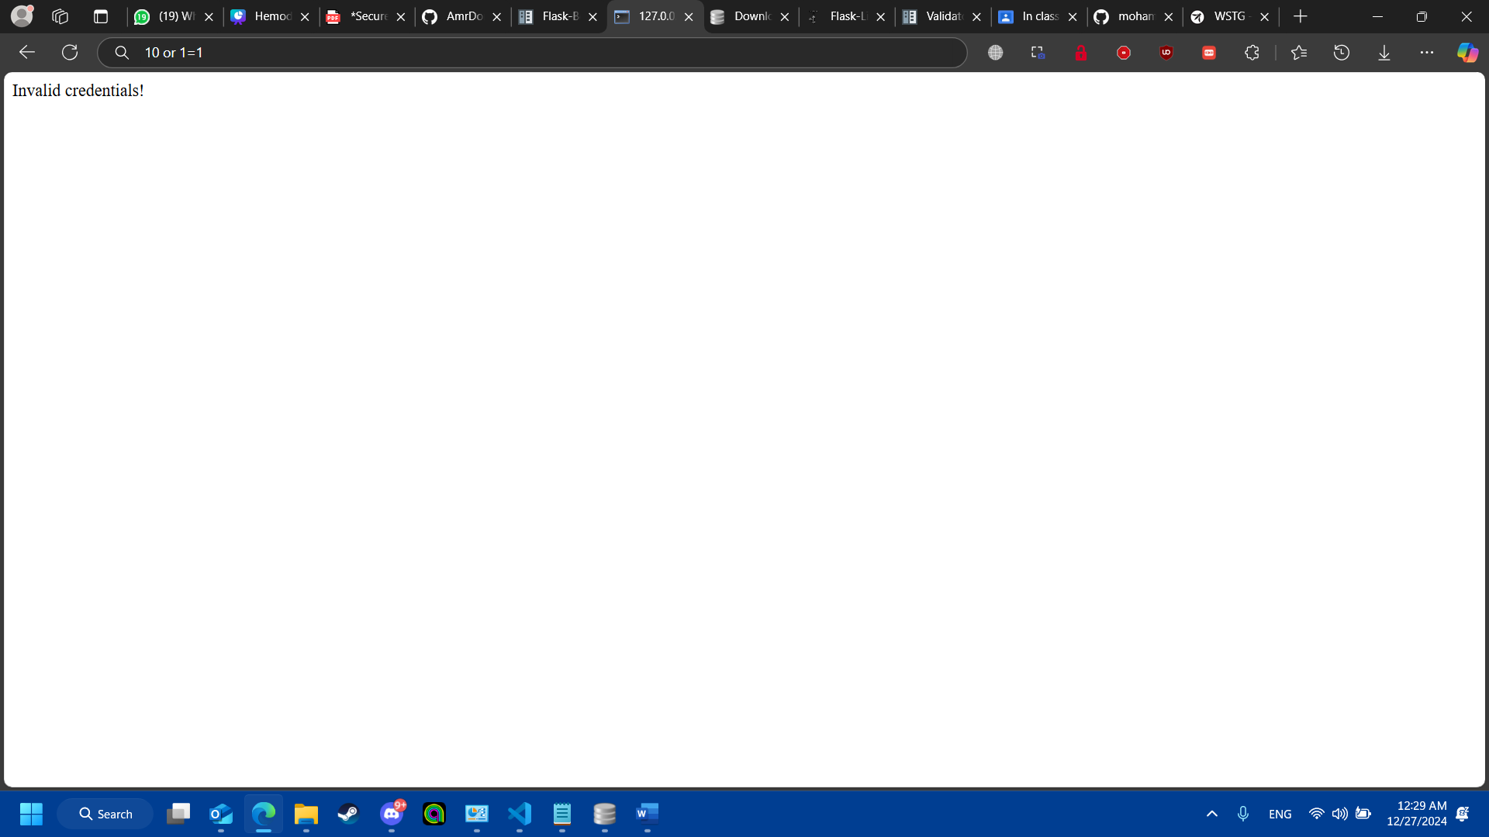

On using username that exists in database and the password “10 or 1=1”, we get invalid credentials because we have escaped the inputs and also we compare for hashes so that’s not a hashed value which returns none

## Unsanitized comments for XSS testing

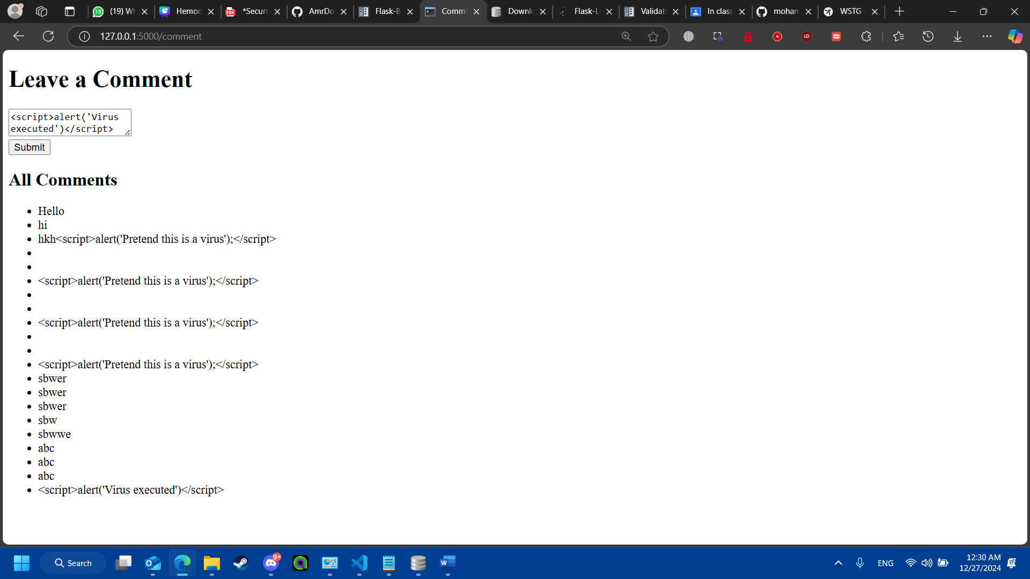

The comment <script>alert(‘Virus executed’)</script> is converted to markdown text so that it is not executed

## CSRF attack on transfer page

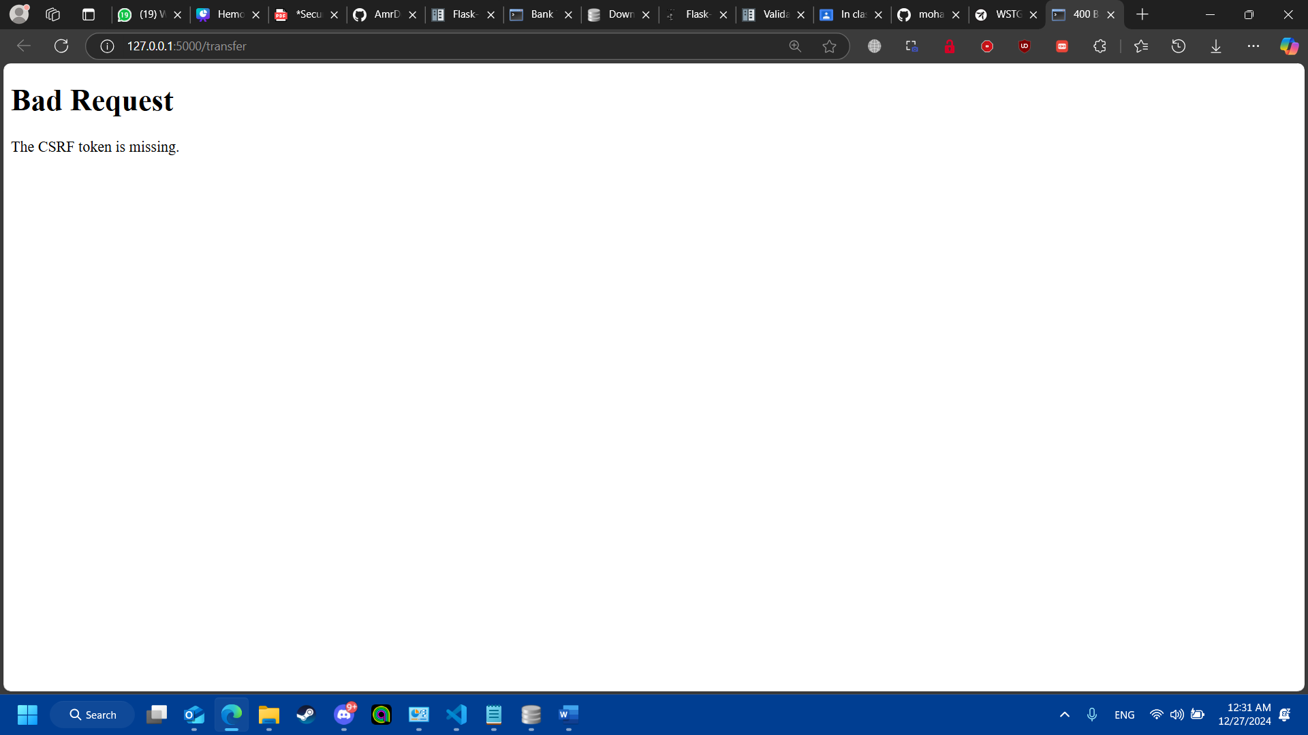

The page is missing a CSRF token which is only granted through the server when redirecting